**EXERCISE 1: CREATING MICROSERVICES FOR ACCOUNT AND LOAN**

**ACCOUNT MICROSERVICE SETUP**

### STEP 1: GENERATE SPRING BOOT PROJECT

* Go to: <https://start.spring.io>
* Fill the form:
  + Group: com.cognizant
  + Artifact: account
  + Dependencies: **Spring Web**, **Spring Boot DevTools**
* Click **Generate**, download and extract the project to:

D:\<Employee_ID>\microservices\account

### STEP 2: OPEN IN VS CODE AND BUILD

* In VS Code → Go to: File > Open Folder → Select the account folder
* Open terminal and run:

mvn clean package

### STEP 3: SET PORT (OPTIONAL IF USING 8080)

**Edit this file:**

src/main/resources/application.properties

**Add:**

server.port=8082

### STEP 4: CREATE CONTROLLER

**Create file:**

src/main/java/com/cognizant/account/controller/AccountController.java

**Paste this code:**

package com.cognizant.account.controller;

import org.springframework.web.bind.annotation.*;

import java.util.Map;

@RestController

@RequestMapping("/accounts")

public class AccountController {

@GetMapping("/{number}")

public Map<String, Object> getAccount(@PathVariable String number) {

return Map.of(

"number", number,

"type", "savings",

"balance", 234343

);

}

}

**OUTPUT:**

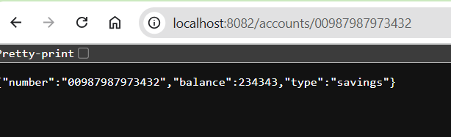

**LOAN MICROSERVICE SETUP**

### STEP 1: GENERATE LOAN PROJECT

* Go to: <https://start.spring.io>
* Use the same config as before
  + Group: com.cognizant
  + Artifact: loan
  + Dependencies: Spring Web, Spring Boot DevTools
* Extract to:

D:\<Employee_ID>\microservices\loan

### STEP 2: SET PORT

**Edit:**

src/main/resources/application.properties

**Add:**

server.port=8081

### STEP 3: CREATE LOAN CONTROLLER

**Create file:**

src/main/java/com/cognizant/loan/controller/LoanController.java

**Paste this:**

package com.cognizant.loan.controller;

import org.springframework.web.bind.annotation.*;

import java.util.Map;

@RestController

@RequestMapping("/loans")

public class LoanController {

@GetMapping("/{number}")

public Map<String, Object> getLoan(@PathVariable String number) {

return Map.of(

"number", number,

"type", "car",

"loan", 400000,

"emi", 3258,

"tenure", 18

);

}

}

### STEP 4: RUN LOAN MICROSERVICE

**In terminal:**

mvn spring-boot:run

**OUTPUT:**

